- SST monthly mean anomaly
  - 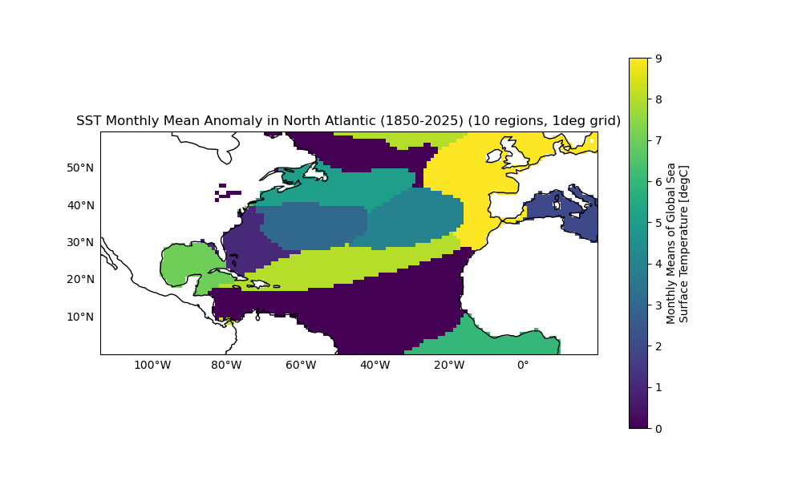
  - Anomaly calculated using the SST.mon.mean dataset (climatological mean calculated across the whole period, then subtracted from the monthly mean dataset)
  - "C:\Research\Clean Repos\SyCLoPS copy\SyCLoPS\images\region_generation\SST_mon_mean_anom.png"
- SST monthly mean anomaly
  - 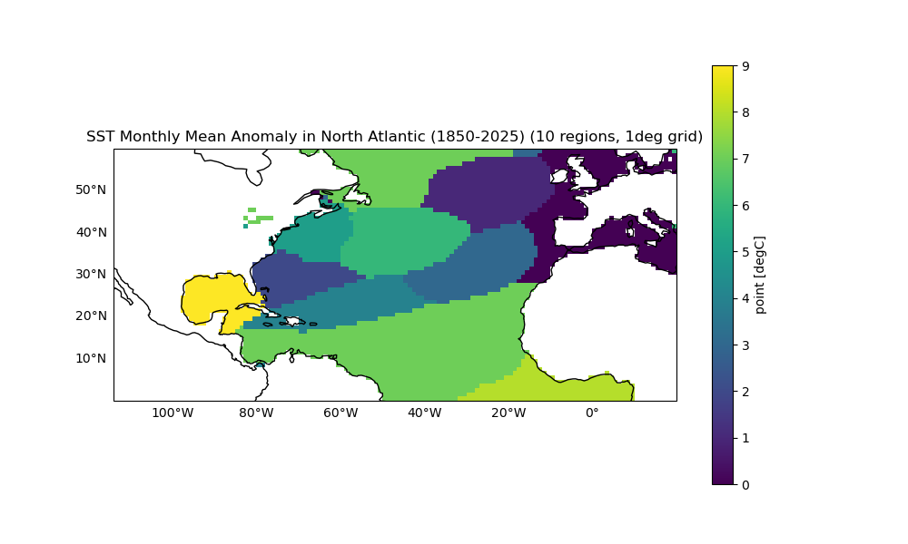
  - Anomaly calculated using the SST ltmm dataset (climatological means calculated across the whole period, then subtracted from the monthly mean dataset)
  - "C:\Research\Clean Repos\SyCLoPS copy\SyCLoPS\images\region_generation\SST_mon_mean_anom_ltmm_v2.png"
- SST monthly mean anomaly with moving window
  - 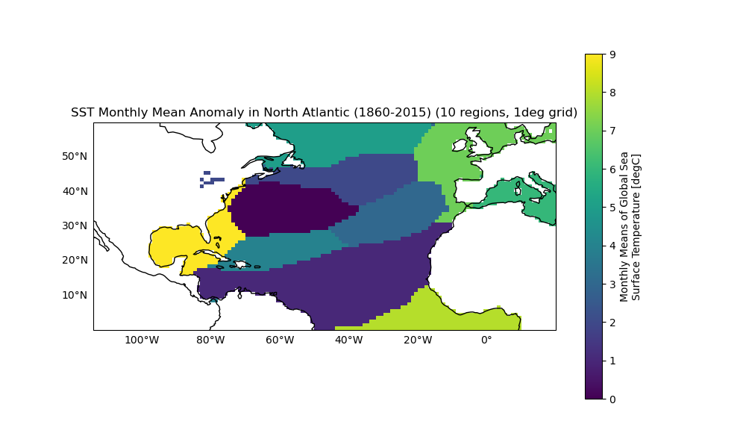
  - Anomaly calculated using the SST monthly mean dataset (climatological means calculated using a moving window; for year n mean uses (year – 10, year + 10), then subtracted from the monthly mean dataset)
  - Monthly mean dataset is trimmed by first and last 10 years to account for moving window calculation
  - "C:\Research\Clean Repos\SyCLoPS copy\SyCLoPS\images\region_generation\SST_mon_mean_anom_moving_window_v2.png"

